Logographic Writing system

what is Logographic Writing system
# Source: Chatgpt (GPT-4-turbo) at [7/21/2025]
A logographic writing system is a type of writing system in which each symbol (called a logogram) represents a word, morpheme (the smallest unit of meaning), or idea, rather than a sound or syllable.

🔍 Key Features of Logographic Writing Systems:
# Source: Chatgpt (GPT-4-turbo) at [7/21/2025]
- Symbol = Meaning
  - Each character stands for a whole word or meaningful unit, not a sound.
  - Example: In Chinese, the character 山 means “mountain” and is pronounced shān.
- Not Based on Pronunciation
  - The same character can be used in different languages or dialects even if the pronunciations differ.
  - Example: The Chinese character 人 means “person” and is pronounced rén in Mandarin, but jin in Japanese.
- Thousands of Characters
  - These systems often require learning thousands of symbols to read and write fluently.

📝 Examples of Logographic Systems:
# Source: Chatgpt (GPT-4-turbo) at [7/21/2025]
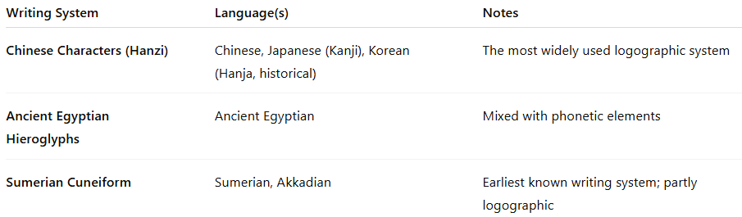
Writing System | Language(s) | Notes
Chinese Characters (Hanzi) | Chinese, Japanese (Kanji), Korean (Hanja, historical) | The most widely used logographic system
Ancient Egyptian Hieroglyphs | Ancient Egyptian | Mixed with phonetic elements
Sumerian Cuneiform | Sumerian, Akkadian | Earliest known writing system; partly logographic

✅ Advantages:
# Source: Chatgpt (GPT-4-turbo) at [7/21/2025]
- Efficient meaning transfer across dialects or even languages
- Can be visually rich and culturally meaningful
- Helps readers guess meaning even without knowing the pronunciation

⚠️ Challenges:
# Source: Chatgpt (GPT-4-turbo) at [7/21/2025]
- Complex to learn due to the large number of symbols
- Slower to write and harder to memorize compared to alphabets or syllabaries
- Requires a strong education system to teach literacy

Logographic vs. Alphabetic vs. Syllabic:
# Source: Chatgpt (GPT-4-turbo) at [7/21/2025]
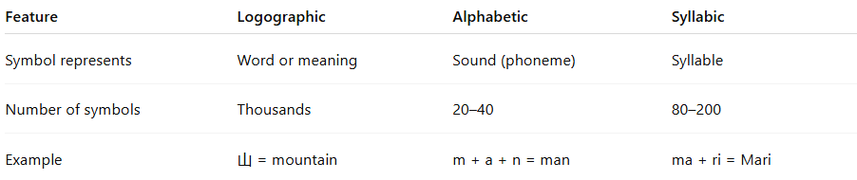
Feature | Logographic | Alphabetic | Syllabic
Symbol represents | Word or meaning | Sound (phoneme) | Syllable
Number of symbols | Thousands | 20–40 | 80–200
Example | 山 = mountain | m + a + n = man | ma + ri = Mari

Summary:
# Source: Chatgpt (GPT-4-turbo) at [7/21/2025]
A logographic writing system uses unique symbols to represent words or morphemes, rather than sounds or syllables. It is meaning-based and often requires learning many symbols, but it can be powerful for communicating across languages or dialects.

